**PRAKTIKUM PEMROGRAMAN BERBASIS WEB (A)**



Oleh :

Muhammad Rachel Fathan Idzhany

4522210071

**Dosen:**

**Adi Wahyu Pribadi, M.Kom.**

**S1 – Teknik Informatika**

**Fakultas Teknik Universitas Pancasila**

**2024/2025**

Koding:

index.php

input.php

koneksi.php

Table.php

Kode SQL:  
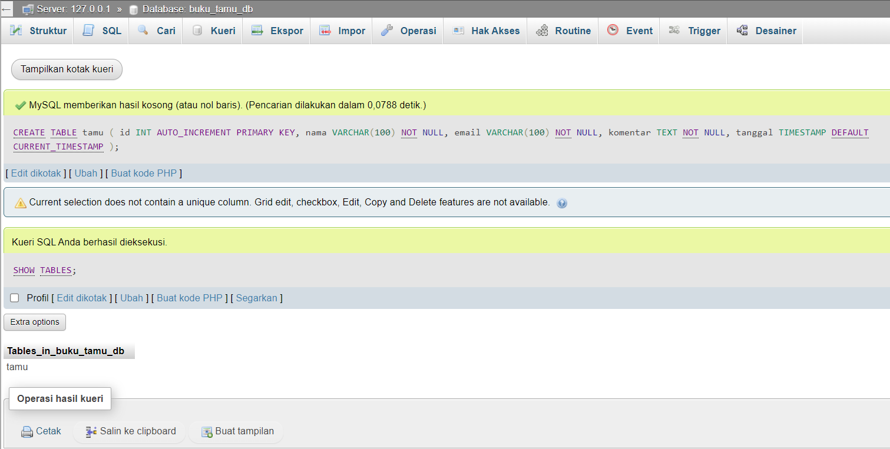

Tampilan Website:

